Ideation Phase

Define the Problem Statements

Date | 06-03-2026
Team ID | LTVIP2026TMIDS48993
Project Name | ToyCraft tales: tableau's vision into toy manufacturer data
Maximum Marks | 2 Marks

Customer Problem Statement Template:
Create a problem statement to understand your customer's point of view. The Customer
Problem Statement template helps you focus on what matters to create experiences people will love.
A well-articulated customer problem statement allows you and your team to find the ideal solution for the challenges your customers face. Throughout the process, you’ll also be able to empathize with your customers, which helps you better understand how they perceive your product or service.
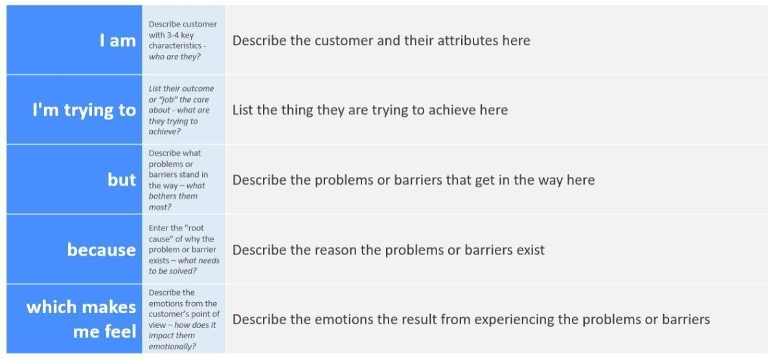
Example:
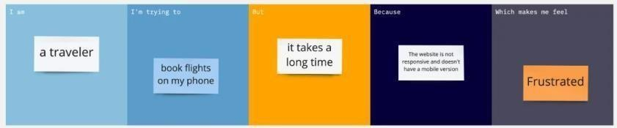

Problem Statement (PS) | I am (Customer) | I’m trying to | But | Because | Which makes me feel
PS-1 | Responsible for monitoring and managing  electricity usage across multiple appliances. | Understand  realtime power consumption and spot unusual  spikes in usage so I can optimize  energy efficiency and reduce monthly bills. | I don’t have intuitive insights or alerts, and I waste time comparing data across different formats or platforms. | The data is  scattered and lacks context—  historical trends, thresholds, or anomaly  explanations. | Frustrated and financially  uncertain when bills are high, and powerless when I can’t clearly see what’s driving  energy waste.
PS-2 | A small business owner who manages a shop with various  electrical devices and machinery. | Monitor daily electricity consumption  across different areas so I can control energy expenses and prevent  overloading. | I struggle to identify which appliances contribute most to my power  usage because my current bills and readings don’t provide device-level  insights. | The data is  aggregated and not real-time, I can’t proactively identify inefficient devices or unusual spikes before they result in high bills or  breakdowns. | Stressed about unpredictable  energy costs and frustrated that I lack visibility into my shop’s energy profile.

